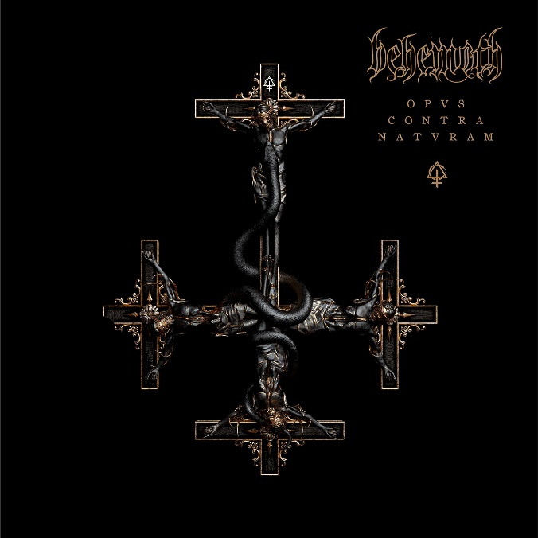

BEHEMOTH

»Opvs Contra Natvram«

OUT: September 16th 2022
Line up: | BEHEMOTH online:
Adam “Nergal” Darski | Lead-Vocals, Guitar  Patrick “Seth” Sztyber | Guitar, Vocals  Tomasz “Orion” Wróblewski | Bass, Vocals  Zbigniew Robert “Inferno” Promiński | Drums & Percussions | https://www.behemoth.pl/  www.instagram.com/behemothofficial/  www.twitter.com/behemothband  www.facebook.com/behemoth
In the annals of metal there is no band more synonymous with an unswerving commitment to the single-minded defiance of expectation than BEHEMOTH. Over the course of their remarkable 31-year career, these Polish hellraisers – spearheaded by Adam Darski, aka Nergal – are more than just the architects of their country’s legendary extreme metal scene. Over the course of three decades and previous 11 albums, Nergal’s singular vision has forged BEHEMOTH into something far more than a mere black metal band. Beyond any confines of genre, they have grown to become nothing less than the personification of rebellion, individuality and unflinching self-expression informed by a literate worldview and worldliness that’s resulted in a locking of horns with everything from the mainstream press to the Polish Catholic church – most notably manifesting in Nergal’s trial for blasphemy in 2010 that only served to expose the deep-seated hypocrisies that his music seeks to challenge. It also highlighted the distinct lack of fucks that he has to give.

Now world-renowned and yet exuberantly underground in their convictions, BEHEMOTH are perhaps the unlikeliest of success stories, but if their stratospheric ascent and hard-won commercial achievement can be attributed to anything, it’s a cast-iron unwillingness to compromise. As Opvs Contra Natvram, their 12th studio release heralds from the rooftops – their longevity is down to a resolute commitment to find new ways to enthrall and inspire their ever-growing legion of latter-day heretics, a determination which shows no signs of erosion. It’s changing times and new battles to fight to which Nergal attributes BEHEMOTH’s unique ability to sound fresh despite their incredible tenure. Therein lies the inspiration for the album’s title and striking cover artwork.

“The album title means going against the current. It’s the negative of the values and morals and ethics that I stand against. I’ve seriously been wrestling with destructive tendencies in pop culture - cancel culture, social media, and tools which I feel are very dangerous weapons in the hands of people who are not competent to judge others. That’s something which I find very destructive and disturbing and extremely limiting coming from an artists’ perspective. This is my middle finger to that. There’s a song on the record called Neo-Spartacvs. Spartacus was one of the most iconic rebels in history who went against the most powerful empire of all time. In the end it’s me screaming, ‘I Am Spartacus, and so are you!’ I want to spark that flame of rebellion. If something seems wrong then stand up to it!”

Never being fully satisfied and never getting comfortable is the basis of the ferocious sounds to be found on Opvs…, too, and as Nergal explains, our viral armageddon afforded him the perfect opportunity to luxuriate in the one thing that BEHEMOTH’s growing empire has never afforded him - time.

“This is the most thoughtful, the most thought-through, the most mature thing we’ve done – it’s quintessentially BEHEMOTH” he says. “It’s just bangers – all meat, no fat.”
Renowned for his meticulous attention to detail and absolute creative control of BEHEMOTH’s world, the depressurised environment afforded by the pandemic meant that for nearly the first time since the band’s inception there was no deadline to observe, allowing for a nearly unprecedented level of attention to the process of writing and recording.

“To me it’s one blurry year, but we’d do these sessions, four five days on just one guitar part, re-record the stuff, go back - that was amazing. Like everyone on the planet, I’ve found myself in a completely unprecedented situation – this paralysis. I haven’t had that much time since I was hospitalized for cancer,” he says, referring to his bout with leukemia in 2010. Of the time leading up to the creation of Opvs, he says: “I’d just come off this massive arena tour with Slipknot which was a big success for us, but I was so worn out and I was calling out to the universe for a remedy. It was something I really needed – to take my time, just breathing and surviving. It felt good. I haven’t done that since ancient times. When you’re a professional musician you’re just living by touring cycles. To be like, ‘this is a good word, let me try 50 others.’ To be fully absorbed into that process. I needed that.”

The 12 chapters of fury that make up Opvs Contra Natvram were written and recorded over the course of a very strange year for the world, a situation which only heightened the level of craft seen in these 43 minutes and 15 seconds of honed, searing wrath. As with previous studio outings, Opvs… was produced by BEHEMOTH with engineering duties undertaken by acclaimed Meshuggah, Dimmu Borgir and In Flames producer Daniel Bergstrand. Mixing, however, involved a new player on the chessboard who you’d be hard-pressed to guess - famed producer and mixer Joe Barresi, a studio legend with a breathtaking credits list which includes Queens of the Stone Age, Nine Inch Nails, Alice in Chains and Tool just to name a few. He was chosen for his celebrated ability to simultaneously preserve a studio recording’s organic feel and identity, and the inspiration for the decision comes from a place you’d least expect.

“So much sounds flat,” says Nergal. “It’s not about how professional you sound, because everything sounds professional and overproduced these days, but you don’t need to make everything perfect – just let it breathe. When you listen to David Bowie, every song has identity – I asked, ‘does the scene really need another album that sounds like everything else?’ Every record I’ve made is me standing in front of motherfucking Mount Everest. Do I make it? Well I have to try.”

And from the sound of Opvs… there is no doubting the artistic summit that Nergal and BEHEMOTH are aiming for. From the colossal energy of opener Post-God Nirvana to the epic and righteous indignation of Ov My Herculean Exile and album-closer Versvs Christvs - a riveting extended track featuring piano and clean vocals which are destined to turn heads BEHEMOTH’s latest is the ultimate soundtrack to these strange and troubled times.

